**Introduction**

My working article is *Spread trading strategies in the crude oil futures market.* I want to follow how the author set up the trading strategy, to fully understand the hedging strategy. Then adding my own thinking to see how can I improve the trading strategies.

In my research, there are two commodities we are working on, WTI and Brent. WTI is a specific grade of crude oil and Brent refer to any or all of the components of the Brent Complex, a physically and financially traded oil market based around the North Sea of Northwest Europe. These two commodities have many similar features. Therefore, if their prices series have some cointegration relationship, then we might be able to set up a trading strategy for their spread. To test this, I downloaded the history prices for WTI and Brent from 1987 to 2020 from Quandl.

Here is overview of the dataset.

Using this data, I compute the coefficient for the two prices series, and it shows very high correlation, which is 0.98988366. It means that we could build trading strategy based on these two commodities.

**Trading straegy**

The idea of the trading strategy we are going to build is to long one commodity and short another one at the same time. The important thing here is what ratio should we implement for the trading. Here I mainly use two strategies and want to test the difference between their performance. Using static hedging ratio and using dynamic hedging ratio.

For the static hedging ratio, it is estimated by using the WTI and Brent prices of the last year before the test period starts and is not changed over the course of the test period.

For the dynamic hedging ratio, dynamic linear model with Kalman filtering and maximum likelihood estimates of the unknown variance of the state equation is employed to constantly update the hedge ratio of the portfolio.

**Set up trading strategy**

For the set up of my trading strategy, when the spread is greater than 2 standard deviation, I open the position. And every time when the spread reaches to the average, I would close the position. Also, I have set up an optional signal, which is loss exit. When the spread is greater than x times standard deviation, I would close the position no matter what.

This graph shows how the spread deviates from the mean, the green line represents 1 standard deviation, red line represents 2 standard deviation from the mean. The line with cyan color is the mean of the spread.

The reason why I choose 2 std, it is because for the mean reverting process, the point further away from mean would have greater chance to get back to the mean. When we open the position when the spread is greater than 2 std, it is highly possible that the spread would reach average, not to make the spread wider, which causes loss to us. After setting up, I would implement the trading strategy for different time period, the rolling windows for the following test are all 100 business days.

**Static hedging strategy**

From 2015 to 2020

The whole time period

**Dynamic hedging strategy**

From 2015 to 2020

The whole time period

We can see that both static and dynamic hedging strategies perform great over the time period, but I want to compare the two of them to see which one have higher profit.

Then I put two graphs together to see which hedging ratio gives the better outcome over different time period.

From 2015 to 2020

From 2015 to 2020, The Static strategy performs better. The static hedging ratio earns 160% profit, but dynamic hedging ratio only earns about 70%.

The whole time period

We can see that the static ratio performs better at the end but dynamic ratio strategy performs better for the most of time. They both earn around 400% profit compared with the beginning.

**Adding Loss exit signal**

Sometimes, we open the position, but the trend of spread does not move toward what we expected. Therefore, we need to implement the loss exit signal so that we can control our loss over the trading. So, does adding loss exit signal into our trading strategies improve our profit? This is a question that I want to test.

The whole time period

Without loss exit signal

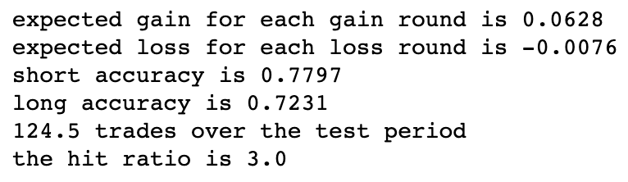

With loss exit signal

For the static hedging strategy, implementing loss exit signal does not improve the profit. On the other hand, it decreases the profit.

The whole time period

Without loss exit signal

With loss exit signal

For the dynamic hedging strategy, it shows the same outcome. I think the possible reason is we test on a comparatively long time period. Without the loss exit signal, it is possible that we could get a profitable closing signal if we wait. But adding up the loss exit signal, we would have to close our position even though we lost money during this round. Therefore, if implementing a trading strategy for a relatively long time period. Not to implement loss exit signal probably is a good idea.

**Conclusion**

After reading carefully the article and following the procedure in the article, I see that the hedging strategy actually works on WTI and Brent. Additionally, with my own setup, I find out that the loss exit signal is not profitable if we are going to trade for the long run. Knowing the idea of the trading strategy, I would be able to test this hedging strategy on other commodities. Since it is certain that there are many commodities which have cointegration relationship in the market. The only problem with my setup for this trading strategy is that it is a low frequency trading strategy, which would test the investor’s endurance over the long period of time